WEST GODAVARI INSTITUTE OF SCIENCE AND ENGINEERING
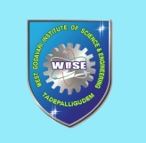
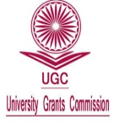
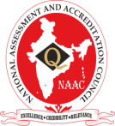
An AUTONOMOUS Institution
(Approved by AICTE, New Delhi and Affiliated to JNTUK-Kakinada)
An ISO 9001 : 2015 Certified College, Accredited ByNAAC
Avapadu, Prakasaraopalem, Nallajerla Mandal, E.G.Dist, A.P–534 112. Cell : 99512 77789, E-mail : principal.wise@gmail.com, Website : www.wise.ac.in

Institute Innovation Council (IIC)

S.No. | Member Name | Designation | Category/Position
1 | Dr. M.Aravindkumar | Principal | Head of the Institute (HOI)
2 | Dr.A.S.Prasad | Head of MBA Dept. | President
3 | Dr.Vaishnavi | Teaching | Member
4 | Mr.M.Rajesh | Teaching | Member
5 | Mrs.S.Jyothi | Teaching | Member
6 | Mr.K.Jayaramakrishna | Teaching | Member
7 | Mr.S.Rajeev | Teaching | Member
8 | Mr.M.Prasannakumar | Teaching | Member
9 | Mr.P.Chaitanya | Teaching | Member
10 | Mr.R.Gopi Chand | Teaching | Member
11 | Mrs.N.L.Tejaswini | Teaching | Member

